**PRE-STAMPEDE MONITORING AND ALARM SYSTEM USING PIC MICROCONTROLLER**

**ABSTRACT**

The main objective of this project is to develop a pre warning system to avoid stampede in places where large gathering of people take place.

In many religious places, political rallies and places where large public gathering takes place there are chances for stampede to occur due to various reasons. This proposed system warns in advance to authorities about gathering of a large number of people in a particular place before any stampede occurs. This project will help us develop a turbulent pedestrian flow prediction and risk management system in most of pilgrimage places, where stampede is often encountered owing to mass movement. This is achieved when a large number of pressure switches are actuated as the people start gathering in one place. The switches are interfaced to a microcontroller of PIC16F8 family, when a certain number of switches are pressed which exceeds the predefined number then microcontroller generates an output to switch on a buzzer alerting the authorities about a possible stampede. The status is also displayed on the LCD which is duly interfaced to the microcontroller.

Further the project can be enhanced by interfacing a GSM modem to the microcontroller so that a warning message is sent to the concerned authorities via SMS.

**BLOCK DIAGRAM**

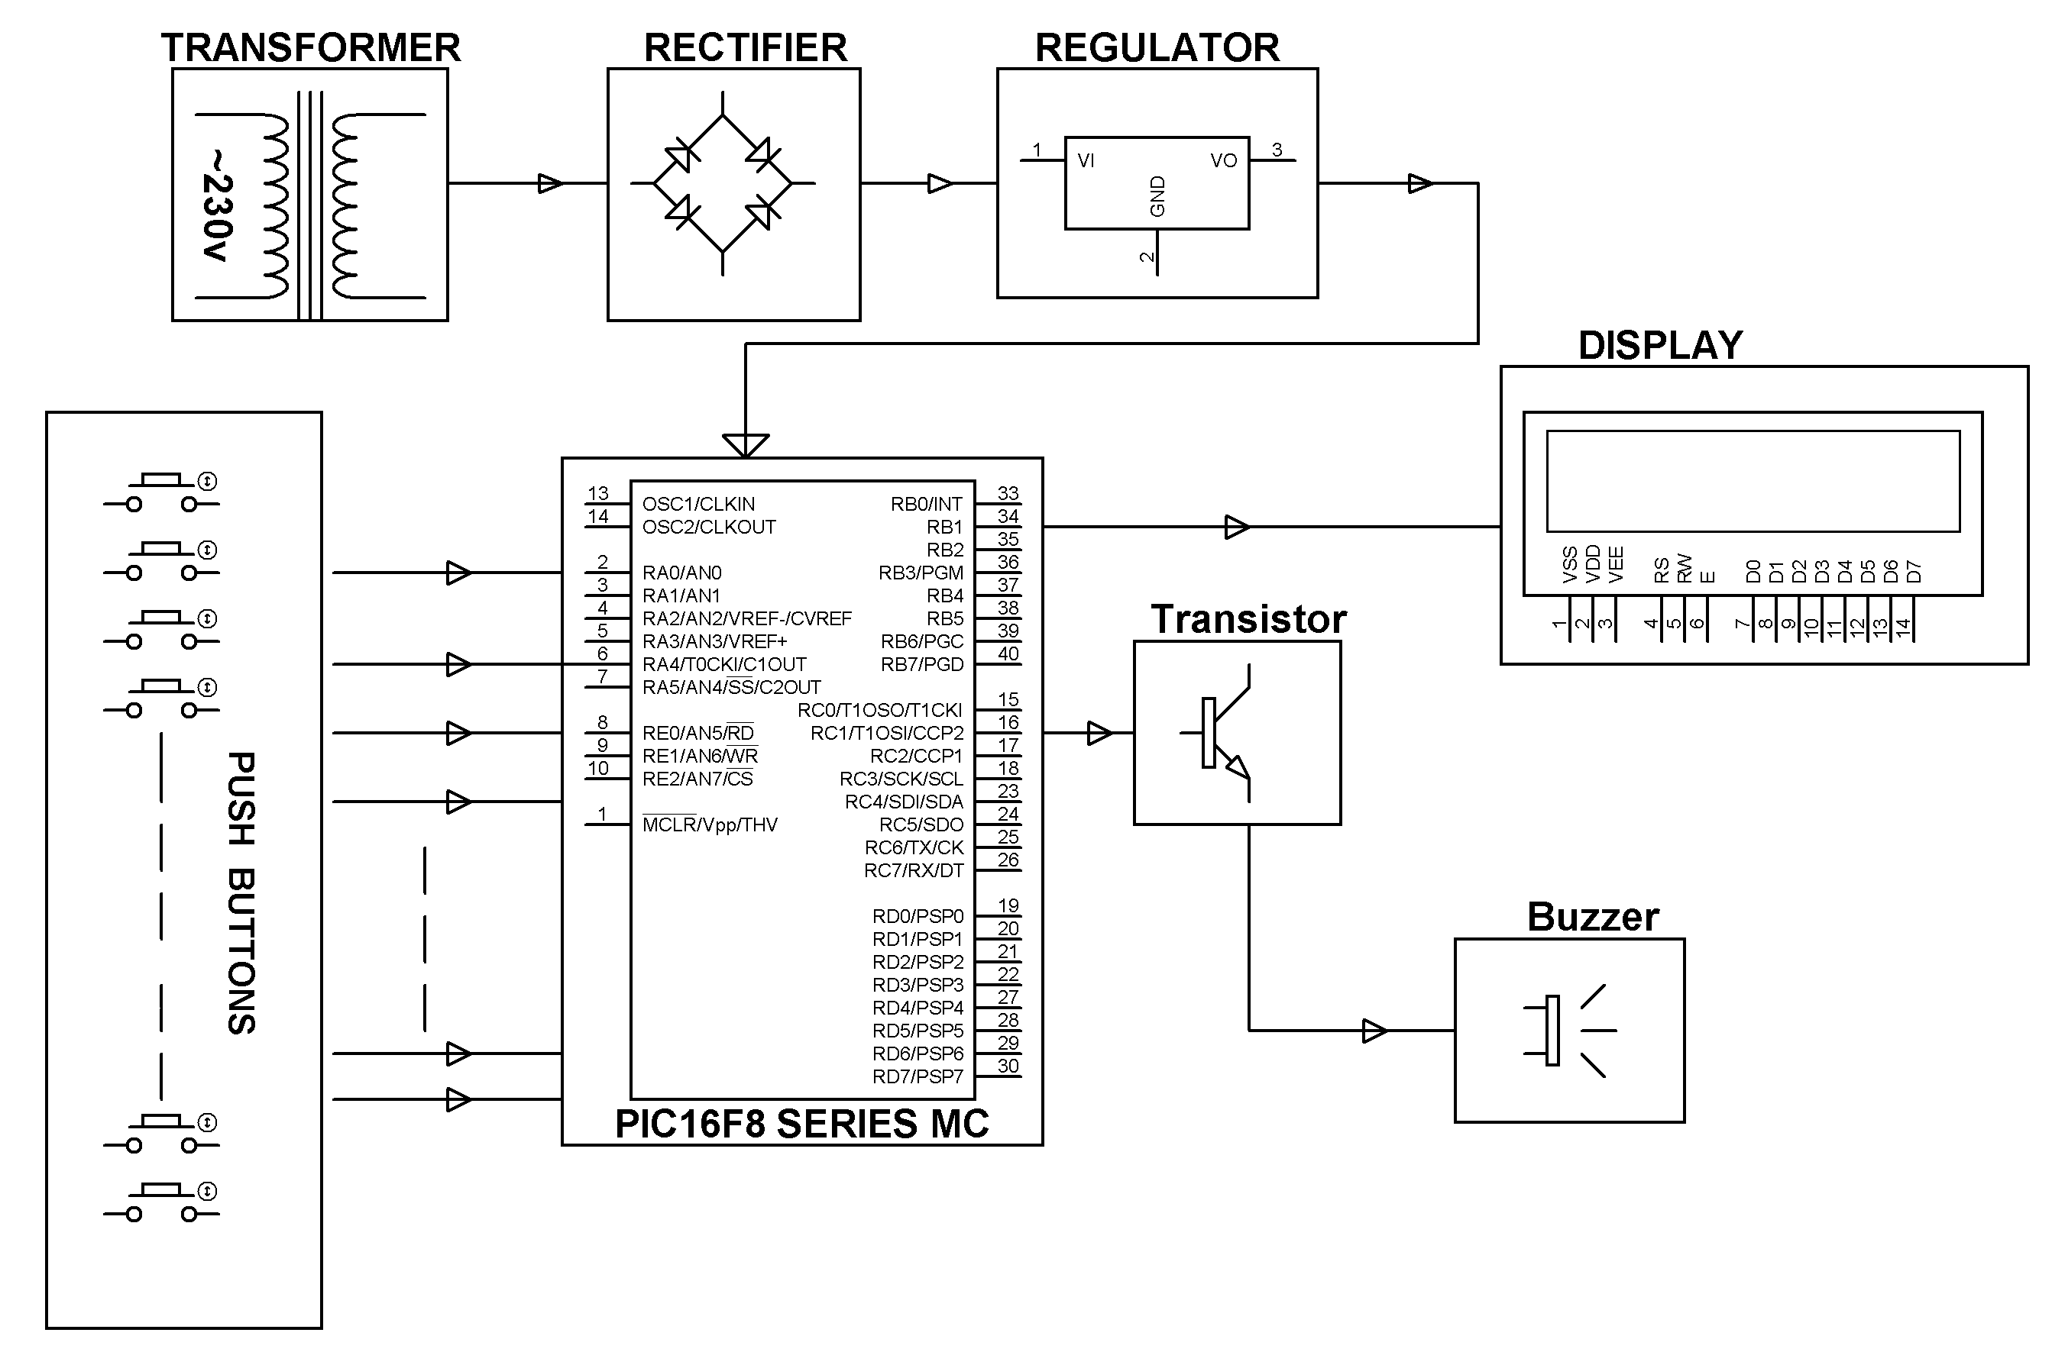

**SOFTWARE REQUIREMENTS**:

MPLAB & CCS C compiler

Languages: Embedded C or Assembly.

**HARDWARE REQUIREMENTS:**

PIC16F8 series Microcontroller, Push Buttons, Transistors, Transformer, Voltage Regulator, LED, LCD, Resistors, Capacitor